|  |  |
| --- | --- |
| **Criteria** | **Definition/details about criteria** |
| Completeness | How well does it meet the requirements? |
| Readability and clarity | How legible (clear) is it? |
| Attractiveness | How visually appealing is the solution’s design? |
| Accuracy | Is the information produced always correct? (Related to validation of user inputs) |
| Accessibility | Are the functions of the user interface easy to find and use? Does the solution cater to those with special needs (disabilities, impairments etc.)? |
| Timeliness | Is the information produced relevant and useful? |
| Communication of message | How clearly is the solution presenting the information that it is producing? |
| Relevance | Does the solution contain the necessary details or elements? |
| Ease of use | Is the user interface intuitive, easy to learn and easy to use? |
| Intuitiveness | How easy is it for users to understand and use the functions of the software? |
| Consistency | Are the elements of the user interface in the same positions and have the same functions across the product? |
| Buildability | Is the solution easy to develop within the scope and constraints placed onto the software solution? |
| Robustness and tolerance | How well does the solution respond to poor usage? |
| Affordance | How forgiving is the solution? (Are users able to undo actions etc) |
| Maintainability | Is the solution easy to maintain? |
| Scalability/flexibility | Can the solution allow for more functions or features without adversely affecting the layout and functioning of the solution? |
| Portability | Can the solution be moved to other operating environments without much effort? |
| Responsiveness | Is the user interface fast?  Does it give feedback to the users? |
| Speed of processing | Is data able to be entered quickly?  Is the output generated quickly? |
| Suitability | Is the solution appropriate for its operating environment? |

**Evaluation for login/register page**

|  |  |  |
| --- | --- | --- |
| **Criteria** | **Design 1** | **Design 2** |
| Completeness | 10 | 10 |
| Readability and clarity | 10 | 8 |
| Attractiveness | 9 | 7 |
| Accuracy | 10 | 5 |
| Accessibility | 8 | 9 |
| Timeliness | 10 | 10 |
| Communication of message | 8 | 7 |
| Relevance | 9 | 7 |
| Ease of use | 9 | 10 |
| Intuitiveness | 9 | 9 |
| Consistency | 10 | 10 |
| Buildability | 9 | 6 |
| Robustness/tolerance | 10 | 7 |
| Affordance | 8 | 8 |
| Maintainability | 10 | 8 |
| Scalability/flexibility | 10 | 9 |
| Portability | 9 | 9 |
| Responsiveness | 7 | 7 |
| Speed of processing | 8 | 10 |
| Suitability | 10 | 10 |
| **Total** | **183** | 166 |

Criteria is based on a scale of 1 – 10 where 1 is the lowest score possible (doesn’t meet criteria, the worst) and 10 is the highest (the best)

From the criteria matrix, **design 1** for the login/register page is shown to be the better design. While the look of both designs are the same, the main feature that sets the designs apart is that in design 2, both the login and register forms are on the same page. This allows for the users to access both the login and the register form at the same time.

In design 1, the register form is only accessible via a small link under the forms and vice versa for accessing the login form on the register page. The second design is more accessible and has a faster speed of processing as users do not have to click small links to get to other pages. However, in implementing both the login and register form on one page, the screen is more crowded which may confuse users, especially since the login and register forms are only differentiated by its header. Regular users also don’t need both forms, just the login form. In this case, design 1 is more suitable for regular users of the solution. These factors explain design 2’s lower scores for attractiveness, communication of message, relevance and scalability/flexibility.

Design 2 is also harder to maintain and implement, most likely having to require the use of CSS containers, grids or floats to keep the two forms apart. The submission and validation of the forms would also be difficult as the username and password inputs are required in both forms. If both forms require inputs before proceeding, the user would be forced to enter in the login form and the register form, which would result in inaccurate data. Even if this problem were to be fixed through checking which form the user interacts with, implementing this check would take time, decreasing the time available to develop the solution’s other features. This explains design 2’s lower scores for accuracy, buildability and maintainability.

Overall, design 1 looks nicer and is easier to read due to its spacious interface, can implement better validation methods and is easier to build and maintain than design 2.

**Evaluation for main (home) page**

|  |  |  |  |
| --- | --- | --- | --- |
| **Criteria** | **Design 1** | **Design 2** | **Design 3** |
| Completeness | 10 | 10 | 10 |
| Readability and clarity | 10 | 9 | 8 |
| Attractiveness | 7 | 8 | 10 |
| Accuracy | 10 | 10 | 10 |
| Accessibility | 8 | 5 | 7 |
| Timeliness | 10 | 10 | 10 |
| Communication of message | 10 | 10 | 10 |
| Relevance | 9 | 8 | 10 |
| Ease of use | 9 | 7 | 10 |
| Intuitiveness | 8 | 10 | 10 |
| Consistency | 10 | 10 | 10 |
| Buildability | 9 | 8 | 7 |
| Robustness/tolerance | 10 | 9 | 10 |
| Affordance | 9 | 9 | 9 |
| Maintainability | 9 | 8 | 7 |
| Scalability/flexibility | 8 | 8 | 7 |
| Portability | 7 | 6 | 7 |
| Responsiveness | 8 | 7 | 8 |
| Speed of processing | 10 | 7 | 8 |
| Suitability | 10 | 10 | 10 |
| **Total** | **181** | 169 | 178 |

Criteria is based on a scale of 1 – 10 where 1 is the lowest score possible (doesn’t meet criteria, the worst) and 10 is the highest (the best)

From the criteria matrix, **design 1** for the main page is shown to be the better design closely followed by design 3. In general, design 1 has larger buttons with a single column for subjects and tasks, design 2 features the usage of a dropdown table and design 3 uses smaller buttons for subjects and tasks which allows for more subjects and tasks to be added.

Considering that the main functionality of the solution is to record the time spent on various subjects and tasks, the buttons that link the subject/task to the timer must be easily accessible. Design 1 features the largest buttons, making it easily accessible for others but only allows for a couple of subjects and tasks to be added before the user has to scroll down, decreasing its ease of use. However, this could be simply fixed by using thinner buttons. On the other hand, design 2 has its subjects/tasks list contained in a dropdown table, which is bothersome to access. Its usage of a dropdown table also means that the ability to delete subjects/tasks must be accessed outside of the main page via a small link at the bottom of the page, further reducing its accessibility. Design 2 also features a slimmer header, which while is more stylish, also decreases its accessibility. Design 3’s layout only allows for small buttons, allowing more subjects and tasks to be added before the user must scroll down. However, this decreases its accessibility as the hitboxes (clickable areas) are also smaller. These factors explain why the other two designs have lower scores in terms of readability/clarity, accessibility and speed of processing.

Out of the three designs, design 1 is the plainest but is much easier to build and maintain than the other designs. The user interface of design 1 is easy to read, simple and doesn’t require much CSS to achieve its look. It features a good usage of space which allows for extra features to be added in the future. Whilst design 3 is the most stylish, featuring a modern layout with the clock as its main feature point, it is the hardest to build and maintain as the subject/task buttons at the bottom of the page need to be constantly resized to fit 2 rows and 3 columns of subjects/tasks to maintain its layout. These factors explain why the other designs have lower scores in terms of buildability and maintainability.

Design 1 has a lower score than the other designs in terms of intuitiveness due to its lack of descriptions explaining what the features are. This could be easily solved by implementing some aspects of the other two designs into design 1 such as design 3’s small caption above the subject/tasks selections.

Overall, design 1 is the simplest to build and maintain and is more accessible and effective than the other two designs. Some modifications to it such thinner buttons and more detailed descriptions could be added to it to improve its functionality and appearance.

**Evaluation for timer pages**

|  |  |  |
| --- | --- | --- |
| **Criteria** | **Design 1** | **Design 2** |
| Completeness | 10 | 10 |
| Readability and clarity | 8 | 10 |
| Attractiveness | 9 | 10 |
| Accuracy | 10 | 10 |
| Accessibility | 9 | 8 |
| Timeliness | 10 | 10 |
| Communication of message | 9 | 10 |
| Relevance | 10 | 10 |
| Ease of use | 9 | 10 |
| Intuitiveness | 8 | 10 |
| Consistency | 10 | 10 |
| Buildability | 8 | 7 |
| Robustness/tolerance | 9 | 9 |
| Affordance | 9 | 9 |
| Maintainability | 10 | 9 |
| Scalability/flexibility | 9 | 10 |
| Portability | 8 | 8 |
| Responsiveness | 8 | 8 |
| Speed of processing | 9 | 9 |
| Suitability | 10 | 10 |
| **Total** | 182 | **187** |

Criteria is based on a scale of 1 – 10 where 1 is the lowest score possible (doesn’t meet criteria, the worst) and 10 is the highest (the best)

From the criteria matrix, **design 2** is shown to be the better design. While the functionality of the designs are the same (they both record the length of time), the appearance and layout of the designs are different. In general, design 1 has a longer container with blue buttons spaced further apart while design 2 is more compact, with coloured buttons placed within its container.

The thick border surrounding the clock’s container in design 2 clearly sets it apart from the background. The coloured buttons used within design 2 are brighter and more eye catching than the blue buttons used in design 1. The green and red buttons in design 2 also follow standard conventions and are more intuitive, with the green button as a ‘start’ button and a red button as a ‘stop’ button, mimicking traffic lights and signs. At a glance, the functions of the start and stop buttons can be conveyed to users. This explains design 2’s higher scores in readability and clarity, attractiveness, communication of message, ease of use and intuitiveness.

In design 2, the buttons are also grouped together, with the start and stop buttons on one side and the reset and done (finished) buttons on the other. This layout makes more sense than the layout presented in design 1 where the functions of the timer (start, stop and reset) are grouped on one side and where the done button is left on the other side. Considering the user’s usage of the timer, placing the buttons apart like in design 2 will prevent the user from making undesirable actions by accidently clicking the reset button instead of the stop button (and therefore losing any progress made on that subject/task). This explains design 2’s higher scores in readability and clarity, communication of message, ease of use and intuitiveness.

However, design 2 has lower scores in terms of accessibility, buildability and maintainability. The compact design of the timer page compared to the wider container presented in design 1 may be difficult to use for users who are motor impaired as the space between hitboxes (clickable areas) are smaller. Users who are green/red colour blind may also have difficultly using design 2. To counter these weaknesses, design 2 could implement a wider container similar to design 1’s and care must be taken to ensure that the functionality of the start and stop buttons can be conveyed even without the green and red colours. In terms of buildability, design 1 is a lot simpler and thus easier to maintain. Design 2’s buttons located within light blue section in the timer’s container, could pose some problems to implement but shouldn’t cause too much trouble.

Overall, design 2 is more visually appealing, intuitive and clearer than design 1. While design 2 is less assessible and more troublesome to implement than design 1, modifications such as a wider timer container and increasing the styling period allocated for this page should counter these problems.

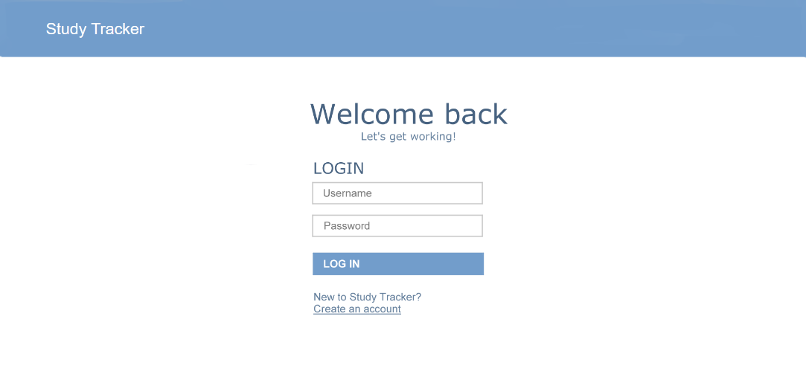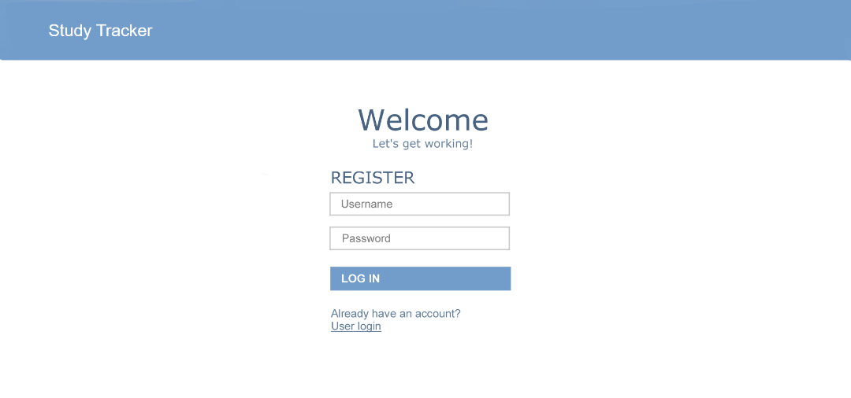

Designs chosen – for annotations and the other alternative designs see the files for Milestone 7

